Assignment 2 : Application Development for Analytics

Attached are the screenshots of the methods along with the output.

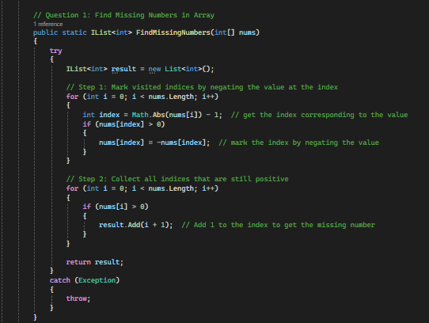

Output of the code:

